**IBM APP CONNECT ENTERPRISE TOOLKIT**

**INSTALLATION (WINDOWS):**

Extract ACE_V11_WinX86_Toolkit zip file. Go in to Extracted file (EAsmbl_image) ,Run ACESetup11.0.0.0 as Administrator.

Accept license agreement -->Next --> Install (Takes 15-20 minutes).

Install IBM WebSphere MQ Explorer Version: 7.5.0.2(Toolkit is Independent of MQ , if you want to use MQ node install it)

**HOW TO CREATE INTEGRATION SERVER:**

After installation open toolkit(IBM App Connect Enterprise Toolkit 11.0.0.0).

To create integration server open console (IBM App Connect Enterprise Console 11.0.0.0)

1. First we have to create working directory,

**mqsicreateworkdir C:\myaceworkdir**

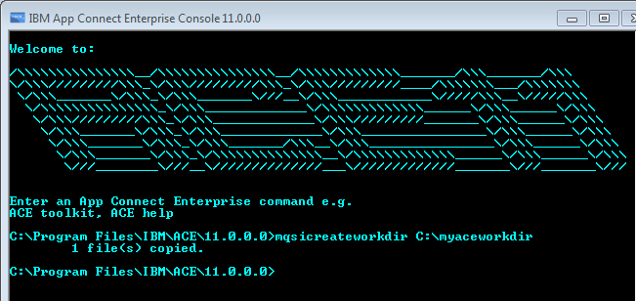

The above command creates myaceworkdir in C: dirve and in myaceworkdir it creates folders config,log,override,run (holds deployed applications)and a file server.conf.yaml.

**server.conf.yaml** file is configuration file for Integration server. Open this file using notepad++ to do configurations for integration server.

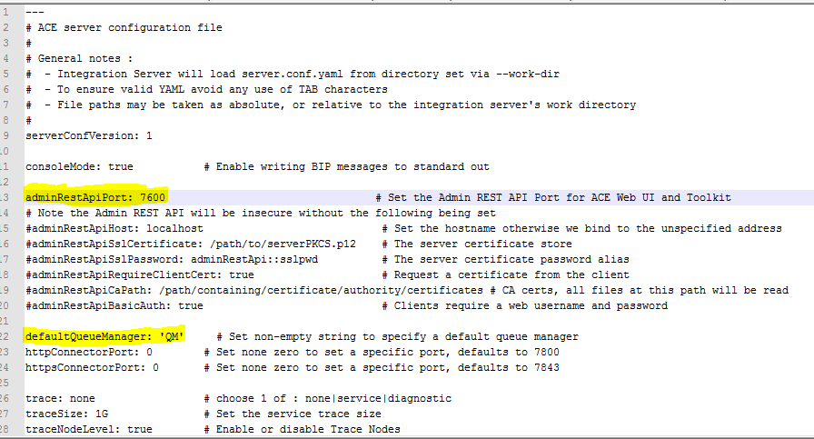

The default port number for Integration server is 7600.

Give Queue Manager name in single quotes (this case QueueManager name is 'QM').

Save file.After saving file We have to validate it.To validate open any browser search YAML validator. Copy entire **server.conf.yaml** file data and paste it in the YAML validator. Validator will tell you whether it is a valid file or not.

1. Next create integration server

**IntegrationServer Myserver --work-dir C:\myaceworkdir**



**Note: Don't close console After you run this command. If you close this, Integration server will be stopped.**

**The above command is for Creating and starting the Integration server.**

**To stop Integration server press crtl+c in console Where integration server is running.**

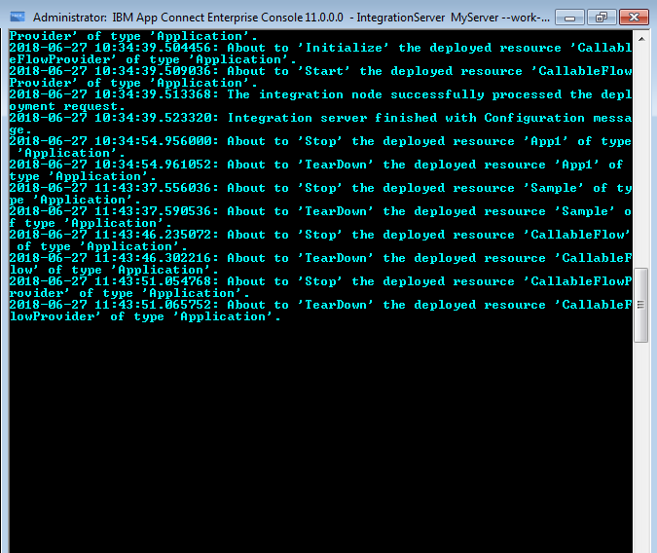

**The above screenshot shows running console**

MyServer has been created and started, now we have to connect to it.To do so go to Toolkit, Right click on Integration Server in Administration perspective-->Click on Connect to integration server. Give host name and port number.

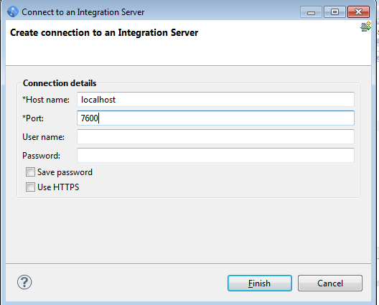

Finish.(No need of username and password).

Now you can see MyServer under Integration Servers in Toolkit.

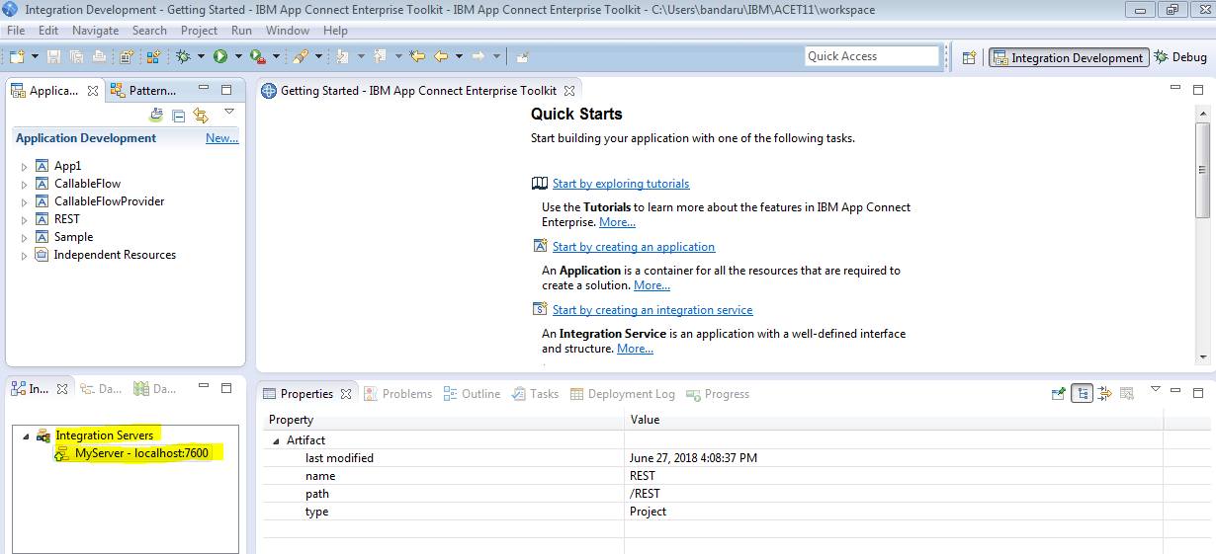

The MyServer is ready to accept deployment requests.

**HOW TO ENABLE DEBUGGING MODE :**

Go to C:\myaceworkdir open server.conf.yaml file in notepad ++ .

Give any port number for jvmDebugport (in this case i have given 7000)

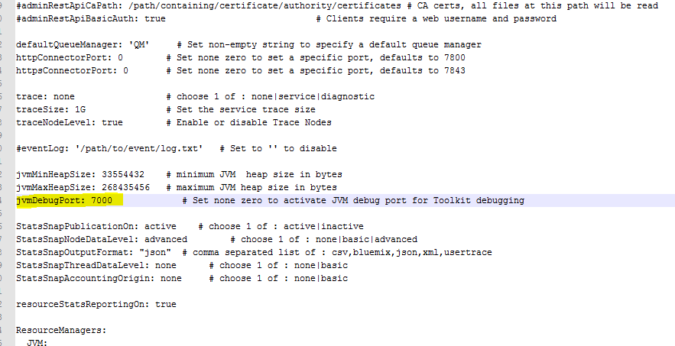

Save file.After saving file We have to validate it.To validate open any browser search YAML validator. Copy entire **server.conf.yaml** file data and paste it in the YAML validator. Validator will tell you whether it is a valid file or not. Now stop and start the Integration server.

To stop server press crtl+c in the console where MyServer i s running.

To start server Run this below command again,

**IntegrationServer Myserver --work-dir C:\myaceworkdir**

The above command starts MYserver.Now,Connect to Myserver in toolkit.

Now go to toolkit,Go to Run-->Debug configurations-->Double click on IBM App Connect Enterprise Debug.

Click on connect, give host name port number(the same port which we have given in yaml file).

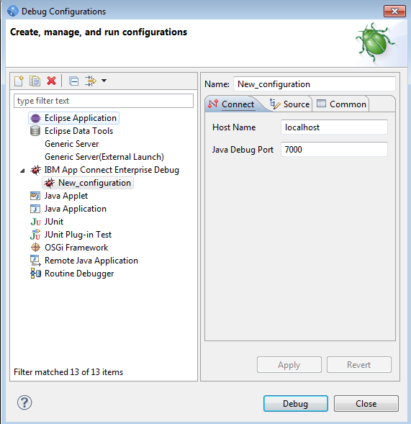

Next go to Source tab-->Add-->Message flow container-->OK-->Select the applications which you want to debug-->ok-->Apply-->Debug.

**WEBUSER INTERFACE:**

Using webUser Interface we can control ,deploy, monitor the Applications.

To Enable few features in Webuser interface Go to **server.conf.yaml** file make changes as shown in below screen shot.

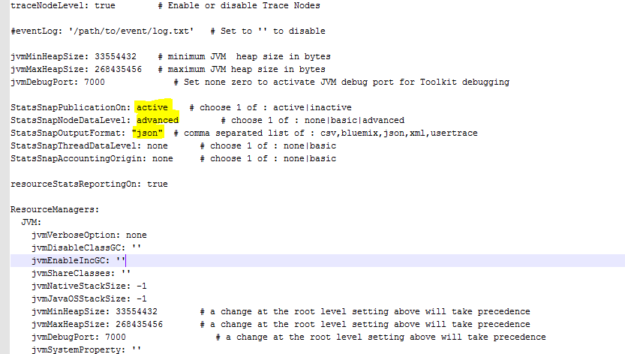

Save file .After saving file We have to validate it. To validate open any browser search YAML validator. Copy entire **server.conf.yaml** file data and paste it in the YAML validator. Validator will tell you whether it is a valid file or not. Now stop and start the Integration server.

Stop and start the Integration server.

To stop server press crtl+c in the console where MyServer i s running.

To start server Run this below command again,

**IntegrationServer Myserver --work-dir C:\myaceworkdir**

Refresh IntegrationServer in toolkit.

In the toolkit ,Right click on Myserver-->Start Webuser Interface.

IBM app connect will be opened in browser.

**CALLABLE FLOW NODES IN IIB11**

First u have to change the configuration file as above said.. u have set default queuemanager in server.conf.yaml then create a calling flow first

**CALLING FLOW:**

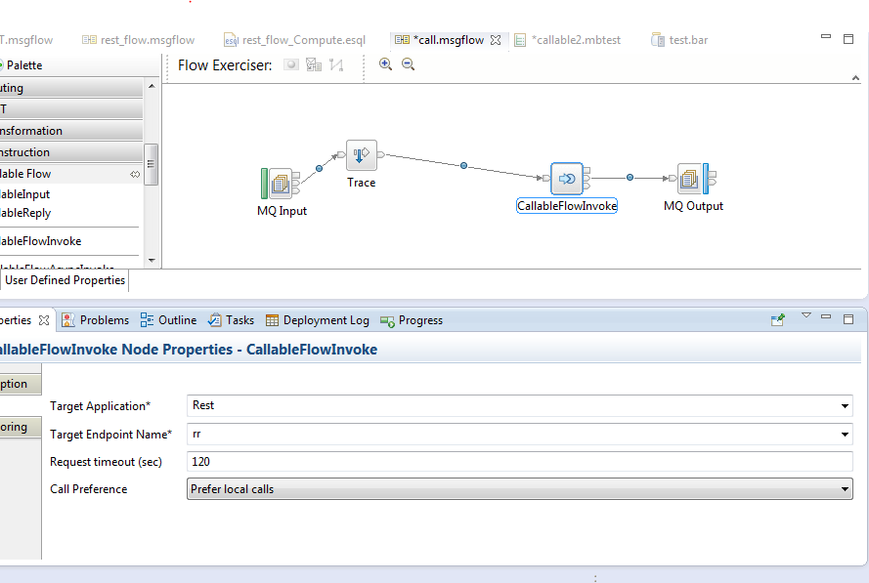

In callable flow invoke properties u have give service provider name is target application name and mention the target endpoint name also any name u have to write then call preference means the both applications in single integration server u have to mention call preference prefer local calls otherwise remote local calls.Then it is automatically use the service of callable flow

**CALLABLE FLOW:**

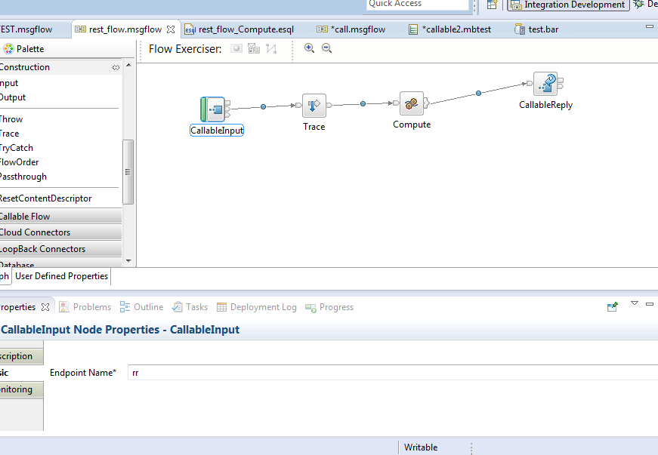

endpoint name must same in calling flow...

And give the response to calling flow and it is stored mqout.